

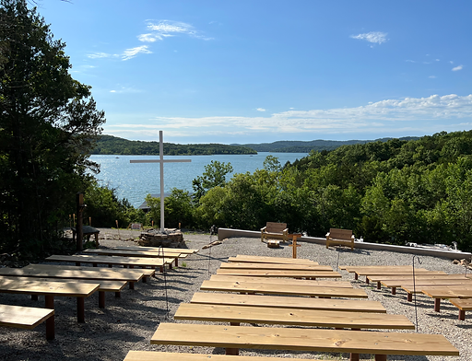

# CAMP DATES: **JULY 18-20, 2025**

# AGES: **YOUNG ADULTS AGES 19-23**

# PRICE: **$155 (includes $5 online processing fee)**

# TO REGISTER: **CAMPTABLEROCK.COM/RECONNECT**